BAINBRIDGE TOWNSHIP

BERRIEN COUNTY,
MICHIGAN

GENERAL DEVELOPMENT PLAN UPDATE
2014

BAINBRIDGE COMMUNITY VISION

● Preserve and encourage historical agricultural character of the
Township while allowing for open space opportunities for housing.

● Carefully evaluate potential expansion of commercial and
industrial base.

BAINBRIDGE TOWNSHIP
BERRIEN COUNTY, MICHIGAN
7315 Territorial & Bainbridge Center Roads
Watervliet, Michigan 49098
269-468-8040

PLANNING COMMISSION MEMBERS

Greg Grear, Chair
Dale Kreitner, Vice Chair
Melissa Morlock, Secretary
Don Baiers, Commissioner
Ron Bjes, Commissioner
Neal Kreitner, Commissioner
Charles LaSata, Commissioner

TOWNSHIP BOARD OF TRUSTEES

Jerry Jollay, Supervisor
Patty Hiler-Molter, Clerk
Nancy Weber, Treasurer
Donald Baiers, Trustee
John Yetzke, Trustee

ZONING ADMINISTRATOR

Ross Rogien

Prepared with Assistance Provided by:
Attorney David Peterson, Sr.
1014 Main Street
St. Joseph, Michigan 49085
269-982-7719

SECTION ONE

INTRODUCTION

BACKGROUND
The original Bainbridge Township Master Land Use Plan was prepared in 1975. It was first updated in the mid 1980’s. It was reviewed and presented as the Bainbridge Township General Development Plan in 1995. The current plan document, which identifies and describes the physical features and land use trends within the Township was once again reviewed and adopted on October 6, 2003.

The most recent Bainbridge Township General Development Plan from 2009 identifies and describes the physical features and land use trends within the Township and characterizes the population expected to reside in the Township by the year 2020. The General Development Plan is a far ranging document which was developed after considerable review of data, surveys and considerable discussion. The Planning Commission considered the results of a major community survey in which the residents of Bainbridge Township expressed their opinions and desires of what the Planning Commission should consider in completing the General Development Plan in 2003.

Township residents expressed their concern that it was very important to encourage the protection of agricultural farmland in the Township. To continue the practice of upholding the inherent right of the agricultural community to operate under generally recognized agricultural practices as well as maintaining the rural character of the Township while providing future

residential growth opportunities. As a result of this input and discussions, the Bainbridge Township Planning Commission and the Township Board of Trustees created a map that describes how it is desired the Township should continue to develop by the year 2020. This information was also critical in allowing for the development of establishing growth policies, development standards as well as creating a designation of a Farmland and Open Space Preservation Program.

The General Development Plan that was enacted in 2003 was a far ranging document. In addition to serving as a statement of how the Township wishes to develop in the future, it is used by the Planning Commission, Zoning Board of Appeals and Township Board of Trustees as the basis for recommending issuance of special land use permits, variances from strict ordinance terms or rezoning of land as provided by the Township Zoning Ordinance. The plan served as the Bainbridge Township “official” guide for further development and acts as the primary measurement tool for the rezoning of any parcel of land within the Township.

The Planning Enabling Act, PA 33 of 2008, requires the Township Planning Commission to review and update the General Development Plan at five year intervals.

In the past seven years, several of the recommendations set forth in the Recommended Implementation Actions of the 2003 General Development Plan have been accomplished and reviewed in 2009. These include updating of the Zoning Ordinance to include a Cluster Development and Open Space Zoning District, establishing an Agriculture/Open Space Preservation Zoning District, and to encourage Berrien County to establish a county-wide Farmland and Open Space Preservation Program, which is now in place. An effect of this planning process also caused a reduction in minimum lot size in the Agricultural Zone from a ten acre minimum to a five acre minimum.

The General Development Plan also addressed the maintaining and upgrading of the existing Township Hall, but it was inevitable that additional space would be required. The most recent completion in

2007 to the existing Township Hall has not only maintained the character of the original building

it has created a very efficient working environment. It was also recommended by the Plan to consider purchasing additional land adjacent or near the existing Township Hall for future expansion of the Township services in the future. This has been considered and is still under review by the Township Board.

During the past ten years the northerly extension of U.S. 31 has been completed to Napier Avenue immediately west of the Township border. At present, there has been a route proposed to complete the expressway from Napier Avenue to a new intersection on Interstate 94 near Empire Avenue. However, funds are not presently in the budget to finish the extension from Napier Ave. to Interstate 94. No major changes are expected to affect Napier Ave from past experience in Bainbridge Township.

During this period of time, there have been several changes in the economic forces that have affected growth and development throughout the region. The forces include:
- The increased cost of energy and oil related products as they affect the cost of transportation and agricultural production.

- Regional population growth, the desire of individuals seeking open spaces and larger country style lots.

- The completion of U.S. 31 from Napier Avenue to the proposed completion of the final section to directly connect to Interstate 94 near Empire Avenue, may result in some reduction of traffic on Napier Ave in the future.

- The adverse effect of the economy on agricultural pricing and economic impact of energy affecting profitability increasing the desire for farmland to be sold for non-farmland uses.

- The aging of the existing individual owners of agricultural interests where there is no other member of the family desiring to continue a farming interest which again encourages farmland to be sold for non-agricultural uses.

- The availability of sufficient source of labor to profitably harvest agricultural crops.

These and other trends and economic forces are resulting in some demand for residential home sites. There has been some demand for commercial land use in Bainbridge Township in the areas existing in the General Development Plan as set aside for such growth.

UPDATE OBJECTIVE
The objective of this update is to document the review process to make sure that the potential growth projections set forth in the General Development Plan in 2009 are valid. The Planning Commission has reviewed the history of all building permits issued for construction of new residences for the past five years. They have also reviewed all splits of land of five and ten acres in the Agricultural Zones to see the effect on existing farmland. This has shown the actual location of changes in comparison to the assumptions made in the 2003 and 2009 General Development Plan as to areas of expected growth and development in relation to the Napier/U.S. 31 Corridor. A new map and listing of all approved special land use permits has been created to provide information on long range land use in the township.

The Planning Commission used this and other data and input from individual Township residents who participated to establish an updated Future Land Use Plan Map. The Township Planning Commission will make recommendations to the Township Board of Trustees concerning all future land development matters undertaken within the Township.

LEGAL BASIS OF THE PLAN
In Michigan, Townships have the authority to prepare and adopt a “basic plan” describing the future development of the Township pursuant to Public Act 33 of 2008, at Section 7.

The Bainbridge Township General Development Plan, December 14, 2009, fulfilled the definition of a General Development Plan pursuant to MCL 125.3803(g).

PURPOSE AND CONTENT OF THE COMPREHENSIVE PLAN
Section 7 of the Planning Enabling Act, PA 33 of 2008, sets forth the purpose of the plan which is in Subsection (2)
(1) The general purpose of a General Development Plan is to guide and accomplish, in the planning jurisdiction and its environs, development that satisfies all of the following criteria:
(a) Is coordinated, adjusted, harmonious, efficient, and economical.

(b) Considers the character of the planning jurisdiction and its suitability for particular uses, judged in terms of such factors as trends in land and population development.
(c) Will, in accordance with present and future needs, best promote public health, safety, morals, order, convenience, prosperity, and general welfare.
(d) Includes, among other things, promotion of or adequate provision for 1 or more of the following:
(i) A system of transportation to lessen congestion on streets.
(ii) Safety from fire and other dangers.
(iii) Light and air.
(iv) Healthful and convenient distribution of population.
(v) Good civic design and arrangement and wise and efficient expenditure of public funds.
(vi) Public utilities such as sewage disposal and water supply and other public improvements.
(vii) Recreation.
(viii) The use of resources in accordance with their character and adaptability.
Section 33 of the Act provides as follows:
(1) A General Development Plan shall address land use and infrastructure issues and may project 20 years or more into the future. A General Development Plan shall include maps, plats, charts, and descriptive, explanatory, and other related matter and shall show the planning commission's recommendations for the physical development of the planning jurisdiction.

(2) A General Development Plan shall also include those of the following subjects that reasonably can be considered as pertinent to the future development of the planning jurisdiction:

- A land use plan that consists in part of a classification and allocation of land for agriculture, residences, commerce, industry, recreation, ways and grounds, public buildings, schools, soil

conservation, forests, woodlots, open space, wildlife refuges, and other uses and purposes.

(b) The general location, character, and extent of streets, railroads, airports, bicycle paths, pedestrian ways, bridges, waterways, and waterfront developments; sanitary sewers and water supply systems; facilities for flood prevention, drainage, pollution prevention, and maintenance of water levels; and public utilities and structures.

(c) Recommendations as to the general character, extent, and layout of redevelopment or rehabilitation of blighted areas; and the removal, relocation, widening, narrowing, vacating, abandonment, change of use, or extension of streets, grounds, open spaces, buildings, utilities, or other facilities.

As demonstrated by the content of the Act, the current Plan fulfills the legislative requirements of a plan. The preparation of the update advances the content and understanding of new land use recommendations needed to guide Township growth and development in the 21st Century.

DATE OF ADOPTION
Pursuant to Michigan law, it is the duty of the Township Planning Commission to notify all adjoining local units of government and the County Planning Commission of its intent to prepare an update to the Plan. On May 28, 2013 a letter was sent providing official notice and requesting collaboration in the update process to the City of Coloma, the City of Watervliet, and Benton, Watervliet, Coloma, and Pipestone Townships in Berrien County; Keeler Township in Van Buren County and Silver Creek Township in Cass County. Letters were also sent to the Berrien County Planning Commission and each public utility within the Township. Prior to the Planning Commission offering the plan for public comment at the required public hearing, the Planning Commission is required to review the draft plan with the Township Board of Trustees and obtain permission to release the plan for review. A meeting of the Township Board of Trustees was held for this purpose on December 9, 2013 and formal action was granted by the Township Board of Trustees to release the draft for review and public hearing purposes, January 20, 2014 at 7:00 pm. On a copy of the draft plan was sent to each abutting community and the Berrien County Planning Commission requesting their review as required by Section 41(2) of Act 33 of 2008, the Michigan Planning Enabling Act.

The General Development Plan Update has been prepared in conformance with applicable Michigan Law and presented to the public at a public hearing held on January 20, 2014. The Township Planning Commission on January 20, 2014 formally adopted the Plan. The Planning Commission also requested the Township Board of Trustees consider adoption of a motion endorsing the Plan. The Township Board of Trustees approved this motion on February 10, 2014.

SECTION TWO

BACKGROUND OF PRIOR PLANS

In preparation of the 2003 General Development Plan, a survey was conducted to allow residents, property owners and business owners to provide concerns to be addressed by the Planning Commission in preparation of the General Development Plan.

The key findings of the residential survey in 2003 are shown as follows:

TABLE 1 – KEY FINDINGS – RESIDENT SURVEY

Findings showing strong support include:

1. Township planning and zoning is effective in controlling development.
2. The Township should do everything in its power to protect farming and agriculture operation in the
Township, including farmland and open space.
3. The Township should consider formal programs to preserve farmland.
4. The Township should adopt and enforce a property maintenance ordinance.

Findings showing support include:

5. Township planning and zoning should allow for development of farmland for other uses.
6. The Township should allow more commercial development along Napier and M-140.
7. The Township should prohibit all residential development in prime agricultural land areas of the
Township.
8. Taxpayers support the use of Township tax revenue to preserve farmland.

Findings showing no support include:

9. Increased industrial development along Napier and M-140.
10. Development of homes on smaller lots where they are surrounded by permanent preserved open
space or farmland.
11. Township discouragement of construction of homes next to farmland.

Findings addressing lot size preferences include:

12. There is support for the 10 acre minimum residential lot size, followed closely by support
for a 5 acre minimum lot size and mixture of 5 acre and 10 acre minimum residential lot sizes.
13. There is somewhat lesser support for a 2 acre minimum residential lot size.
14. There is no support for a mixture of 2 acre and 5 acre minimum residential lot sizes.

The 1995 General Development Plan provided the basis for the 2003 General Development Plan including growth policies and development standards for agricultural, residential agricultural, low density residential, high density residential, residential mobile home park and commercial zones. The original 1995 Future Land Use Map is reproduced on Page 49.

In addition, a survey was conducted by Township Officials and the Township Planning Commission Consultant to inventory and map all land enrolled in the Farmland and Open Space Preservation Act, P.A. 116 of 1974, as amended. Program and current use of all farmland and open space land.

The results of the survey are shown in the 2002 Agricultural Use Map on Page 51 and Current Ag Use Map on Page 53 and 54. Also incorporated into the research is the Flood Plain/Wetland Map of Bainbridge Township shown on Page 57.

SIGNIFICANCE TO THE 2003 GENERAL DEVELOPMENT PLAN UPDATE
The survey results, public input, and prior concerns of the Planning Commission proved to be almost identical. The immediate issues to be addressed in the 2003 review identified the following:
- Retention of low density agricultural quality of life;

- Protection of agricultural land through a formal Township program prohibiting residential land use in prime agricultural land areas of the Township;

- Increasing commercial land use along Napier Avenue and M-140;

- Minimum lot sizes necessary to retain the current character of the Township in the future.

The 2003 General Development Plan established the following policies:

Policy 1 - Agricultural Lands
To encourage the protection of the agricultural farmland in the Township by continuing to use a minimum lot size sufficiently large enough to discourage development of relatively large residential parcels in the agricultural protection area shown on the Future Land Use Map by establishing and maintaining predominantly agricultural zoning. Consideration may be given to residential developments in the agricultural protection area shown on the Future Land Use Map approved as a cluster or planned unit development, through other zoning tools for those land areas not specifically being used for agricultural purposes and where the non-developed (preservation) land area provides a boundary or buffer so as not to impinge upon adjacent agricultural operations.

Policy 2 - Provision of Residential Development
Provide for a reasonable amount of residential development — development which will appropriately accompany the anticipated relatively low population growth.

Policy 3 - Avoidance of Prime Agricultural Land
Guide urban growth and development toward non-prime agricultural lands, open and unused land, and the least productive agricultural land.

Policy 4 - Minimum Residential Lot Sizes
Require lot sizes that are adequately large enough in size to help prevent earth, ground water, and
surface water pollution, as well as to encourage aesthetically pleasing residential areas.

Policy 5 - Concentrate Commercial Development
Require through zoning techniques, consolidated commercial development within the areas designated for development as shown on the Future Land Use Map. This is intended to prevent scattered development of commercial development within the Township on existing streets and highway frontages in areas that have not previously been designated as commercial areas on the Future Land Use Map.

Policy 6 - Discourage Fractionalization of Farmland
Discourage the fractionalization of agricultural land by scattered residential development.

Policy 7 - Direct Residential, Commercial and Industrial Uses Toward Utility Network
Restrict new high-density residential, commercial and industrial development to areas adjacent to
or near similar type development within the Township until such time as municipal utilities become available, thereby ensures more economical extension of expensive utility systems.

Policy 8 - Recognize Michigan’s Right to Farm Act Provisions
Uphold the inherent right of the farmer to perform generally accepted agricultural and management practices as provided in the Michigan Right to Farm Act, P.A. 93 of 1981(MCL286.A71).

Policy 9 - Industrial Development to be Provided by Others
Due to the lack of infrastructure necessary to support industrial and other related office and dense commercial development, the needs of Township residents for this type of development will be provided by surrounding townships, cities and villages where the adopted Plans support such development.

DEVELOPMENT STANDARDS

Agricultural Lands
- Protect prime agricultural land for agricultural purposes by maintaining the predominantly agricultural zoning in those areas.

- Protect existing agricultural activities, through zoning techniques, from infringement of other land uses.

- Provide an area which is suitable for part-time farming and residential-agricultural activities.

- Allow for a certain amount of “open space,” cluster residential developments that protect and enhance the Township’s rural character and aesthetic appeal without imposing upon large tracts of agricultural lands and farming practices.

- Provide a transition between the more urbanizing development and the agricultural areas.

- Support Berrien County’s established a Farmland Preservation Program in which the Township can pursue the acquisition of Farmland Conservation Easements for the purchase of farmland development rights.

Low Density Residential
- Encourage low density residential development to locate adjacent to or within existing “built-up” areas of the Township.

- Provide a neighborhood environment for families.

- Require lots large enough to provide for on-site septic tank absorption fields and protect against ground saturation by sewage pollutants.

- Recognize that it is the intent of the Township not to seek the installation of utilities to service areas designated for Low-Density Residential development.

High Density Residential
- Encourage new development to locate near existing concentrations of development to allow for efficient extension of public utilities at such time as they become available.

- Require connection to municipal sewer and water in areas designated for high density residential development when such utilities become available.

- Protect residential areas from encroachment by incompatible land uses and non- residential traffic to promote pleasant neighborhood environments.

Residential Mobile Home Park
- Provide an alternative to typical single family housing developments.

- Encourage new development to locate near the unincorporated Millburg area since utility extensions are most likely to come from Benton Township.

- Require connection to municipal sewer and water if it becomes available.

Commercial
- Encourage commercial uses to take place in the area of established neighborhood centers to help facilitate economical extensions of municipal utilities when they become available.

- Encourage the clustering of commercial areas to avoid scattered, sprawling commercial areas along road frontage.

- Encourage commercial development to locate along major thoroughfares to avoid excessive traffic in residential and agricultural areas.

- Encourage new commercial enterprises to develop near existing commercial areas to protect the prime agricultural land and rural character of the Township.

Industrial
- Encourage industrial uses to locate in designated industrial and other business location in abutting townships, cities and villages, where the provision of utilities and where local governments seek to locate such development pursuant to approved plans.

R E V I E W

SUMMARY OF FUTURE LAND USE PLAN AS SET FORTH
IN 2003 FOR THE YEAR 2020

The 2020 Future Land Use Map set forth major changes over the 1995 map (Page 49 and 59). These changes reflected the following understandings:
- Designation of a Farmland and Open Space Preservation Program as a land use;

- Combination of all former residential home site development areas into a single residential category of land use (leaving density of development - low, high and mobile home park, to be defined in the zoning ordinance);

- Minor expansions to the size of the geographic areas shown for commercial and industrial land uses when compared to the geographic areas shown on the current Future Land Use Map;

- “Mapping” of a Farmland and Open Space land use preservation area upon request by a property owner and acceptance of the land use by formal decision of the Planning Commission and Township Board of Trustees upon implementation of a preservation program in the Township;

- The implementation of a Farmland and Open Space preservation program and the implementation of a purchase of development rights in the Township;

- Acknowledgment that the provision of major shopping needs of Township residents and most other commercial and industrial development needs of Township residents will be provided by new and existing businesses located within Benton Township, Coloma Township, Watervliet Township and the communities of Benton Harbor, Coloma, Eau Claire, Sister Lakes, and Watervliet;

- Recognition that the majority of daily convenience shopping and other related commercial service needs of Township residents should be located along Napier Avenue, North Branch Road, Territorial Road, and M-140 in areas shown on the Future Land Use Map;

- Recognition that future new industrial development should be confined to the existing areas as shown on the Future Land Use Map;

- The plan recognizes the Township has upgraded and maintains the present Township Hall for Administrative Purposes. While it is our desire not to allow high density population and it is the intent of the Township Board to continue to use contract services for emergency services such as fire, police, and ambulance services consideration should be given to potential expansion requirements. It would be prudent to consider the purchase of additional property adjacent to, or near the present Township Hall for future use.

SECTION THREE

2013 SOCIO-ECONOMIC CONSIDERATIONS

The 2013 review process included the socio-economic analysis based upon the most current data available from the 2010 U.S. Census. The data used for this review is from the 2009 General Development Plan and up-dated information from Bainbridge Township records.

HISTORIC POPULATION GROWTH TRENDS

Total Township population, as recorded in each decennial census from 1950 to 2010 is shown in Table 2. As shown by this data, the period of 1960 through 1970 saw the greatest increase in population. In the late 1980's, population growth began to lessen probably due to actions of the Township to regulate new residential development and the decision to implement a large minimum lot size for residential development in the agricultural portion of the Township.

TABLE 2 – TOWNSHIP POPULATION COUNTS 1950 - 2000
YEAR | Count | Increase  <Decrease> | % Change
1950 | 2,194 | --- | ---
1960 | 2,503 | 309 | 14.1
1970 | 2,784 | 281 | 11.2
1980 | 2,879 | 95 | 3.4
1990 | 2,865 | <14> | <0.5>
2000 | 3,132 | 267 | 9.32
2010 2850 (282) (9.89)
Source: U.S. Census

The controlled growth trend evidenced by decreased population count between 1980 and 1990 has been reversed in 2000 as demonstrated by the increase of 267 residents during the last census period. It is interesting to note that in each of the census periods in which population growth has occurred the actual number of new residents has been somewhat similar, between 270 and 310 people, this equals between 103 and 120 housing units each census period.

For comparison purposes, Berrien County grew by 1,075 residents between 2000 and 2010, a declined growth rate of 3.5 percent. Historically since 1950, the Township has grown at a percentage rate in excess of the County growth rate, 42.75% and 40.41% respectively. For the period of 2000 to 2010 the Township rate was significantly lower than the percentage growth rate of the County, 9.3% and 0.7% respectively. In the 2010 census, Berrien County’s actual loss was 5,642 in population. Over the past 10 years, reflecting the general effect of loss of employment possibilities in manufacturing, industry and overall economy has effected growth.

PROJECTED POPULATION YEAR 2035
The Southwestern Michigan (Regional Planning) Commission (SMC) is the repository for U.S. Census data within the three counties which comprise southwest Michigan. In this capacity, the Southwestern Michigan Commission distributes population projections prepared by the Michigan Department of Management and Budget, Office of the State Demographer. Table 3 illustrates population projections for the years 2000, 2010, 2020 and 2030, as issued by the Southwestern Michigan Commission. The Southwest Regional Planning Commission Projects Berrien County will have a population of 165,432 residents by 2030. This is an increase of 8,619 from the census count of 2010, showing 156,813. This is an average growth of 431 residents per year over the next 20 years for the entire county.

TABLE 3 – TOWNSHIP 2020 POPULATION PROJECTIONS
Population 1990 – US Census ………………………………………………………….2,865
Population 2000 – US Census ………………………………………………………….3,132
2000 Population Projection (DMB) …………………………………………………….2,887
2010 Population Projection (DMB) …………………………………………………….2,861
2020 Population Projection (DMB) …………………………………………………….2,828
Sources: U.S. Census, Claritas, Inc., and State of Michigan, Department of
Management and Budget (DMB), Office of the State Demographer.

PROJECTED INCREASE IN HOUSEHOLDS FROM 2009 GENERAL DEVELOPMENT PLAN
Table 4 contains information concerning the number of new households expected to locate in the Township according to projections by Claritas, Inc. Claritas was used by the Planning Commission to establish an anticipated increase of 145 households by 2010. What the actual results showed was a decrease of 148 households to a low of 1,139 in 2010 which is almost equal to the 2010 actual census count. Using the anticipated increase of a maximum of 125 individual residents and an average 2.5 residents per house there could be as few as 50 additional households established in Bainbridge Township by 2035

PROJECTED INCREASE IN HOUSEHOLDS BY 2006
Table 4 contains information concerning the number of new households expected to locate in the Township by the year 2006 as projected by Claritas, Inc. As shown, the total number of households in the Township was expected to increase by 145.
TABLE 4 – HOUSEHOLD PROJECTIONS - 2010
Population, 2000 …………………………………………………………………………… 3,132
Population, 2006 ……………………………………………………………………………..3,252
Increase in population, 2001 - 2006 ……………………………………………………………120
Population, 2010 …………………………………………………………………………….. 2850
Households, 2000 …………………………………………………………………………… 1,142
Households, 2006 …………………………………………………………………………… 1,287
Increase in Households, 2000 – 2006 ………………………………………………………… 145
Households, 2010 …………………………………………………………………………….1,139
Sources: U.S. Census
Decrease in Households………………………………………………………………………<148>
Projected Households, 2035………………………………………………………………….. 1189

TRENDS IN PERSONS PER HOUSEHOLD RATIO
The number of persons living in each individual household has experienced a downward trend during the past several census periods. Data showing the number of persons per household is shown in Table 5.
TABLE 5 – PERSONS PER
HOUSEHOLD TRENDS
YEAR | RATIO
1970 | 3.19
1980 | 2.86
1990 | 2.65
2000 | 2.56
2006 | 2.53
2010 2.52
Source: U.S. Census

As shown by this data, the ratio decreased during the Census period between 1980 and 1990 by 0.21 persons. The ratio also decreased again between 1990 and 2000 by 0.09 persons.

Interestingly, this ratio was expected to decrease between 2000 and 2006. These trends document the continued aging of the population within the Township and the growing tendency toward smaller sized households.

DEMOGRAPHIC PROFILE OF THE TOWNSHIP
The Bureau of Census recently released additional information to aid the understanding of the population and housing characteristics of the Township.

Of specific importance to the future of the Township is data concerning the age of the population and the head of each household. Bainbridge Township historically developed as a Township of families within close proximity to jobs offered by agricultural producers in the Township or jobs located in the Benton Harbor - St. Joseph Metropolitan Area.

As the children of these families grew older and moved away, the parents remained. The historical data concerning the number of persons residing in each household documents this trend. This trend is projected to reverse itself in the future by new families moving into the Township to repeat the cycle of raising a family in the Township.

Sex and Racial Composition
Table 6 presents data showing the number of males and females plus the racial composition of Township residents. As shown by this data, there are slightly more males in the population. The Township racial composition is 0.6 percent black and 95.5 percent white with a small representation of other minorities.

DEMOGRAPHIC PROFILES OF MICHIGAN COUNTIES

TABLE 6 – SEX AND RACIAL COMPOSITION OF
TOWNSHIP RESIDENTS 2010
Sex | Count | Percent
Male | 1465 | 51.4
Female | 1385 | 48.6
Race
White | 2607 - 2850 | 91.4
Black | 20 | 0.70
American Indian | 16 | 0.56
Asian & Pacific Islander | 6 | 0.17
Others / two or more races | 57 | 2.00
Source: U.S. Census
Percent total may not equal 100% due to rounding.

Age of Township Residents
The U.S. Census data for the Year 2000 displayed in Table 7 shows the age of Township residents by various age groupings. The information shows the Township represents an elderly and youthful community at the same time. About 27 percent of the population in 2000 is school age or younger children. More than 32 percent of the residents are aged between 20 and 44 years, which is the population age group where most families raise children. About 14 percent of the population is of retirement age and almost 14 percent in the pre-retirement age group.

TABLE 7 – AGE COMPOSITION OF
TOWNSHIP RESIDENTS – 2010
Age Grouping | Count | Percent Total
0 – 4 years | 159 | 5.57
5 – 9 years | 171 | 6.00
10 – 19 years | 345 | 12.10
20 – 24 years | 145 | 5.08
25 – 34 years | 278 | 9.75
35 – 44 years | 328 | 11.50
45 - 54 years | 463 | 16.24
55 – 59 years | 219 | 7.68
60 – 64 years | 215 | 7.54
65 – 84 years | 463 | 16.59
85 and more years | 64 | 2.24
Total | 2850 | 100.29
Source: U.S. Census
Percent total may not equal 100% due to rounding.

The significance of this information is that the Township has a rather large number of families
with children. The Township will continue to be faced with supplying services for younger
families. Additionally, the number of residents at or nearing retirement age is also a significant
proportion of the population of the Township. This trend indicates the need for senior services
will be in greater demand. Also, the ability of retirees to maintain single family homes may
become more difficult in the future.

Educational Attainment
Another important characteristic of the population of the Township is their educational attainment. Information from the 2010 U.S. Census displayed in Table 8, shows residents of the Township hold higher education attainment levels than in 2000 with a decrease in the number of residents attending high school grades 9-12 and not receiving a diploma with an overall increase in having some college or a college degree.

TABLE 8 – EDUCATIONAL
ATTAINMENT – 2010
Educational Attainment | Count | % Total
9th to 12th grade, no diploma | 345 | 18.54
Some college | 415 | 22.31
High School Graduate | 610 | 32.90
College Degree | 495 | 26.61
Total – persons 25+ years | 1860 | 100.36
Source: U.S. Census
Percent total may not equal 100% due to rounding.

Householder and Family Information
An important consideration for the planning of any community is gaining a complete understanding of the number and type of households within the community. The number of households is an indicator of the number and type of housing units that will be required to house residents of the Township. Table 9 contains information concerning the number of households
and the average number of persons residing in each household and family. The average person per household ratio consistent with the 2000 U.S. Census data. This follows the overall national trend of fewer persons per household and the increase of single person households across the nation.

TABLE 9 – HOUSEHOLD DATA
COMPARISON 2000 2010
Number of Households …………………………………… 1,142 1,139
Persons per Household …………………………………… 2.56 2.47
Total Families ……………………………………………. 833 794
Persons per family ……………………………………….. 2.91 2.93
Source: U.S. Census

DATA OF PRIOR CENSUS NOT AVAILABLE

Housing Unit Information
The U.S. Census recorded a total of 1,295 housing units in the Township in 2000. This was a decrease of 16 units reported in the 1990.The 2010 Census data shows a total of occupied housing units of 1,331, an increase of 36 housing units in the last 10 years.

Data concerning the status of the units is contained in Table 10. As shown by this data, there is a dominance of owner-occupied housing units 73.17 percent with rental units amounting to 13.14 percent of the total. The percentage of rental units has remained consistent with the occupied housing numbers over the past 10 years.

TABLE 10 – HOUSING UNIT COMPARISON
2000 - 2010
Total Housing Units - 2000 ----------------------------------------------- 1295
Total Housing Units - 2010------------------------------------------------ 1331
Total Vacant Housing Units - 2000 ----------------------------------------111
Total Vacant Housing Untis - 2010 ----------------------------------------192
Total Occupied Housing Units - 2000 ------------------------------------1142
Total Occupied Housing Units - 2010 ------------------------------------1331
Total Owner Occupied Housing Units - 2000 -----------------------------981
Total Owner Occupied Housing Units - 2010 -----------------------------974
Total Renter Occupied Housing Units - 2000 ---------------------------- 161
Total Renter Occupied Housing Units - 2010 ---------------------------- 175

Tenure in Dwelling Unit
The 2000 U.S. Census provides information concerning the date when the household first moved
into the Township and how long they have occupied their current dwelling unit. This information is helpful in gaining an understanding of the propensity of Township residents to relocate, referred to as the annual “movership” rate. This information shows that about 32 percent of the households moved into the Township after 1995. It is important to note that 37 percent of Township residents moved into the Township before 1980. The 2010 Census shows that since 1995, 42 percent of the households are new residents in the township. The data shows a major increase in residents for the period from 1990 – 1994 and a reduced number of residents from

1969-1989 and prior years. It can be concluded that these persons are likely the original dwelling owners and represent the group that chose the Township as their long-term home location and most likely are at or near retirement age. These persons are likely candidates for housing assistance and alternative living accommodations desired by seniors.

TABLE 11 – TENURE IN CURRENT
DWELLING UNIT – 2010

Year Moved Into Unit | Number | Percent
1999 to March 2000 | 188 | 19.58
1995 to 1998 | 214 | 22.29
1990 to 1994 | 217 | 22.60
1980 to 1989 | 129 | 13.49
1970 to 1979 | 50 | 5.2
Before 1969 | 162 | 16.8
American Fact Finder
Percent total may not equal 100% due to rounding.

Type of Housing Units and Value of Owner-Occupied Units
The last descriptor of housing in the Township is the number of units within each residential structure and the value of owner-occupied housing units. This data is shown in Tables 12 and 13. Data in Table 12 documents the predominance of single family housing units, amounting to almost eighty-three percent of all housing units. Rental housing represents about 17% of the occupied residences and the housing stock in the Township.

TABLE 12 – 2010
HOUSING TYPE
OCCUPIED HOUSING UNITS

Owner Occupied | 796 | 82.9%
Renter Occupied | 164 | 17.1%
TOTAL OCCUPIED HOUSING UNITS | 960
American Fact Finer

Table 13 reports data concerning the value of housing units which indicates at the time of the 2000 Census, more than 71 percent of the homes were valued between $50,000 and $150,000.
The median value of home was estimated to be $90,300 in 2000, an increase from $51,600 in 1990. Table 13 reports data concerning the value of housing units which indicates, at the time of the 2010 Census, there were substantial differences in housing values and a number of houses in
each value unit. While the number of homes valued at $50,000 or less remains somewhat consistent there were major changes in the $50,000 plus areas. This reflects the increase in the value of housing due to inflation and market pressure prior to 2010 but does not reflect the loss of value in housing prices due to market conditions, loss of employment, and mortgage foreclosures that were yet to fully effect prices and values in the 2010 Census. The median value of a home in Bainbridge Township increased from $90,300 in 2000 to $135,000 in 2010, but it most likely has declined under present market conditions.

TABLE 13 – VALUE OF OWNER OCCUPIED
HOUSING UNITS 2010
Value of Unit | Number | Percent Total
Less Than $50,000 | 70 | 8.8
$50,000 to $99,999 | 122 | 15.3
$100,000 to $149,999 | 254 | 31.9
$150,000 to $199,999 | 157 | 19.7
$2000,000 to $299,999 | 61 | 7.7
$300,000 or More | 9 | 1.1
American Fact Finder
Percent total may not equal 100% due to rounding.

Civilian Labor Force Information
Information gathered in the 2000 Census shows the Township had a civilian labor force of 1,558 people; an increase from the 1,511 reported in1990. Unemployment was reported to be 6.3 percent in 2000 slightly lower than the 6.9 percent reported in 1990. Data for the type of positions held by residents is shown in Table 14. This information shows that a majority of Township residents are employed in management, professions and related positions or production, transportation and material movement positions.

TALE 14 – OCCUPATION OF EMPLOYED TOWNSHIP RESIDENTS – 2000 - 2010
Total Employed Persons ……………………………1,558 - 1311 | 100.0%
Managerial, Professional and Related ………………….388 - 398 | 26.6% - 30.4%
Sales and Office Occupations ………………………….293 - 220 | 20.1% - 16.8%
Service Occupations ………………………………….. 128 - 191 | 8.8% - 14.6%
Farming, Forestry and Fishing …………………………131 - 239 | 9.0% - 18.2%
Construction, Extraction and Maintenance …………...177 - 304 | 12.1% - 23.2%
Production, Transportation and Material Moving …….. 343 - 198 | 23.5% - 15.1%
Source: U.S. Census 1990 Employees 16 years and older & American Fact Finder
Percent total may not equal 100% due to rounding.

Household, Family and Per Capita Income Data
Claritas, Inc., reports several items of data which are used to show the amount of available income within the Township used for housing and shopping expenses. This information is contained in Table 15. As shown by the data, the growth of income of the residents during the period of 1989 and 2001 has been very generous, ranging between 77 to 84 percent during the ten-year period, on a household and family basis. This same trend is projected to occur as future incomes are expected to grow between 25 and 26 percent in the next five years.

TABLE 15 – SELECTED INCOME DATA – 1989, 2001 & 2006

Item / Year | 1989 | 2001 | %  Change | 2006 | %  Change
Average Household Income | $32,561 | $57,691 | 77.2% | $72,207 | 25.2%
Average Family Income | $38,014 | $67,564 | 77.7% | $84,622 | 25.2%
Per Capita Income | $12,297 | $22,568 | 83.5% | $28,577 | 26.6%
Source: U.S. Census 1990 & Claritas, Inc.

TREND OF TAXABLE VALUATION
One major indicator of the wealth and economic stability of any community is the total assessed valuation of the residential, agricultural, commercial and industrial properties in the Township.

For a Township to borrow funds for improvements, the amount and annual growth of the total taxable valuation is reviewed by lenders when making a decision to lend funds to a community. All communities want a strong growth trend in the total amount of assessed valuation. This allows the Township to borrow funds at reasonable rates for making long-term improvements for roads, streets, water, sewer, parks or other Township improvements.

In Table 16, the most current and past four years total assessed valuation for residential, commercial, industrial and vacant land within the Township is reported. As shown by this data, the Township experienced a steady increase in total taxable valuation during the period between 2003 and 2007. The most recent valuation increase, between 2006 and 2007 was 4.9 percent. This information shows the Township should be viewed as a good candidate for the borrowing of funds for infrastructure improvements and other Township needs, if determined necessary by the Township Board of Trustees.
TOTAL EQUALIZED ASSESSED VALUATION TRENDS

Tax Year | Amount
2007 / 2013 | $127,087,346 / 126,132,263
2006 / 2012 | $121,163,793 / 120,669,550
2005 / 2011 | $109,992,848 / 127,476,800
2004 / 2010 | $97,245,456 / 121,451,300
2003 / 2009 | $89,174,682 / 131,851,400

Table 17 shows the top ten tax payers of the Township. These ten taxpayers represent more than $5,796,610 of the total tax base of the Township or 6.7 percent.

TABLE 17 – TOP TEN
TAXPAYERS IN 2008

Property | Tax Value
Indiana Michigan, Power Company | $1,193,312
Vincent & Karen Parrinello | 880,989
Greg Orchards & Produce | 866,410
Douglas & Kimberlee Lane | 517,010
George Lane Trust | 450,579
Leon & Debra Barber, Jr. | 442,368
Roland & Jill Williams | 394,968
Warren Willmeng | 320,082
Carlton Schooley | 316,000
Total | $5,796,670
Source: Township Assessor

SECTION FOUR

IMPLICATION OF RECOMMENDED ACTIONS OF
THE 2003-2009 General Development Plan

The Planning Commission has implemented the necessary zoning tools which allow for cluster development and open space zoning districts within the agricultural zones as identified in the 2025 Future Land Use Map.

Bainbridge Township has also implemented a Farmland Preservation Program, which allows for the voluntary sale or purchase of development rights. In addition, Berrien County has now established an ordinance and governing body which all local units of government may elect to participate.

A representative of the Bainbridge Township Planning Commission participated with the Benton Township group considering such an ordinance for Napier Avenue. Review of the proposed zoning ordinance to consider establishment of a corridor traffic management designation has shown there is not significant need to establish such an ordinance at this time. There has been no completion of the US 31 Bypass construction to connect to I-94 and no commercial development on Napier Avenue.

SECTION 5

AGRICULTURE, FARMLAND OPEN SPACE PROTECTION

INTRODUCTION
In the State of Michigan preservation of agriculture, farmland and open space are significant statewide concerns. In the process of updating a Township Plan, the Planning Commission has certain duties to evaluate the historic role of agriculture, farmland and open space in the Township and the role (if any) of agriculture, farmland and open space in the future. This mandate originates within the Michigan Planning Enabling Act, P.A. 33 of 2008, as amended, where the act declares that one purpose of a Township Plan is to “to encourage the use of resources in accordance with their character and adaptability” to promote the public health, safety and general welfare. This section of the Bainbridge General Development Plan Update addresses the historic policies of the Township toward agriculture and farmland preservation and more current policies toward open space preservation.

DEFINITIONS - AGRICULTURAL AND OPEN SPACE LANDS
The Zoning Enabling Act, P.A. 110 of 2006, as amended and the Farmland and Open Space Preservation Act, P.A. 116 of 1974, as amended by P.A. 262 of 2000, define agriculture lands as:
“Substantially undeveloped land devoted to the production of plants and animals useful to humans, including forage and sod crops, grains; feed crops, and field crops; dairy products; poultry and poultry products; livestock, including breeding and grazing of cattle, swine, and similar animals; berries; herbs; flowers; seeds; grasses; nursery stock; fruits; vegetables; Christmas trees; and other similar uses and activities.”

Open Space defined by the Farmland and Open Space Preservation Act, are lands that meet one of the following definitions:
- “Any undeveloped site included in a national registry of historic places or designated As a historic site pursuant to state or federal law,

- Riverfront ownership subject to designation under part 305,( P.A. 451 of 1990) to the extent that full legal descriptions may be declared open space under the meaning of this part, if the under developed parcel or government lot parcel or portions of the undeveloped parcel or government lot parcel as assessed and owned is affected by that part and lies within 1/4 mile of the river,

- Undeveloped lands designated as environmental areas under part 323, including unregulated portions of those lands,

- Any other area approved by the local governing body, the preservation of which area in its present condition would conserve natural or scenic resources, including the promotion of the conservation of soils, wetlands, and beaches; the enhancement of recreation opportunities; the preservation of historic sites; and idle potential farmland of not less than 40 acres that is substantially undeveloped and because of its soil, terrain, and location is capable of being devoted to agricultural uses as identified by the department of agriculture.”

As demonstrated by these definitions, to a large extent the designation of specific parcels of land that meet these definitions is the responsibility of the Township. Most typically, as historically evidenced by designations shown on former General Development Plan maps, agriculture, farmland and open space lands have been identified by the Planning Commission for land areas, that in the judgment of the Township Planning Commission and Township Board of Trustees, best meet the definitions set forth in the act.

HISTORY OF AGRICULTURE PROTECTION IN BAINBRIDGE TOWNSHIP
The origin of agriculture protection in Bainbridge Township dates back to the Township Plan prepared by the Planning Commission in 1975. The three principals which guided the Plan were Large Lot Zoning, No Utility Installation Policy and Designation of Prime Agricultural Lands.

The policy of No Utility Installation in 1975 was based upon the premise there would only be such public utilities extended from Benton Harbor to possibly serve the Millburg area. There were some tracts of rural land available near Millburg which would not support septic systems but could be building sites if public utilities were available. The other area considered was the area around Pipestone Lake.

The 1975 and later General Development Plans have designated a large portion of the Township as having prime agricultural land due to soil types, elevation and climate totaling more than 22 sections of the Township. Another factor was the Public Act 116 Farmland and Open Space Preservation Act had over 3,830 acres enrolled in 1995.

The growth policies set forth in Plans from 1975 forward were established to preserve agricultural lands, encourage preservation of the Township’s agricultural lands by requiring relatively large residential parcels. It was the policy to guide urban growth and development away from prime agricultural lands to the open and unused least productive areas identified within the agricultural lands. It has been the policy to discourage scattered development of scattered urban development and to uphold the inherent right of the agricultural community to perform generally recognized agricultural practices as provided in the Michigan Right to Farm Act P.A. of 1981.

The 1968 Bainbridge Township Zoning Ordinance allowed wherever there was a road, the road frontage to a depth of 330 feet was designated as eligible for single family development. This practice resulted in small residential lots being developed along road frontages. The effect of this is very evident along the main roads in the Township. It is for this reason Large Lot Zoning was incorporated in future planning in 1975 to eliminate the total use of small lots in what is now considered prime agricultural areas.

The 1975 and 1995 Plans designated over 22 sections of the Township as prime agricultural lands. To encourage development away from prime agriculture land for single family

residences, in 1975 the Planning Commission established a Residential Agricultural District with a minimum lot size of 5 acres. This area shown on the Future Land Use Map (Page 59) was in an area that has very limited agricultural use. The area has been expanded twice since 1975 by request of property owners.

To protect prime agricultural lands in 1975 the Planning Commission established a policy requiring a 10 acre minimum lot size for individual single family homes in the prime agricultural areas of the Township. This policy did allow for one lot to be “split” from the original parcel as long as there was a minimum of 150 feet width at the road from an existing lot of record as of December 1, 1975. The remaining lot of record must have a minimum of 300 feet road frontage and have a minimum of 10 acres of land remaining. All future “lot splits” must contain a minimum of 10 acres.

The Planning Commission, by this action, felt the 1 small lot split would allow for family members interested in farming to build on a small lot if it was not practical to use 10 acres of land for such a single family dwelling. It was also felt by allowing for the sale of 10 acre “lot splits” the land owner could sell off land that could possibly not be farmed due to wet conditions or topographic challenges of wood lots. It was also considered a method of scattering single family residences throughout the prime agricultural areas on agricultural land that was not productive.

The official policy of Bainbridge Township has been “it should do everything within its power to support agriculture business operations and to preserve certain farmlands for the future” to:
- Retain the historic economic base of the Township,

- Retain the low-density rural agricultural character of the Township,

- Serve as “good stewards of the land” and preserve the Township’s unique and vital natural resources for the future,

- Retain an environment where agriculture business operations are not conflicted by proximity of residential and other land uses, and

- Implement the wishes of the residents of the Township to assist agriculture business operations, protect farmland and promote open space with the goal of retaining the rural agriculture character of Bainbridge Township in the future.

Farmland Preservation. Upon request of an applicant, parcels of property will be mapped on the Future Land Use Map when the specific parcels of land have been approved by the Planning Commission and Township Board of Trustees and when the parcels of land meet one or more of the following characteristics:
- The parcels of land subject to the determination fulfill the definition of farmland as set forth by Michigan law,

- Has adequate acreage to be economically employed for agricultural purposes either separately or in combination with other abutting or close-by properties under control by a single land owner or farmer,

- Has soils, elevation and climatic characteristics unique to the agricultural use of the land,

- The land is, has been, or could be enrolled in the P.A. 116 Farmland and Open Space program,

- The farmer and/or property owner is able to make an affirmative statement relative to the desire to protect and preserve the land for agriculture and farm purposes,

- The Planning Commission has determined that the specific parcels of land contribute to the formation of a unified large block of farmland within the Township (opposed to an isolated property surrounded by other land uses), and

- The subject properties are of sufficient value to the agricultural character of Bainbridge that ultimate preservation of the land through one or more federal, state or local preservation programs may be initiated by the Township, when such programs become available.

Open Space Land Preservation. Upon request of an applicant, parcels of property will be mapped on the Future Land Use Map when the specific parcels of land have been approved by the Planning Commission and Township Board of Trustees and when the parcels of land meet one or more of the following characteristics:
- The parcels of land subject to the determination fulfill the definition of open space as set forth by Michigan law including regulated wetlands or floodplains,

- Has adequate acreage to be environmentally significant either separately or in combination with other abutting or close-by properties under control by a single land owner,

- Has soils, elevation and climatic or other characteristics that are significantly vital and important to the environment,

- The land is, has been, or can be enrolled in the P.A. 116 Farmland and Open Space Program or acquired under the terms of any federal or state land conservation program,

- The property owner is able to make an affirmative statement relative to the desire to protect and preserve the land for open space purposes,

- The land is so located that it does not interfere with farmland preservation or agriculture production on land areas designated for protection pursuant to the guidelines of this Plan,

- The Planning Commission has determined that the specific parcels of land contribute to the formation of a coordinated open space plan within the Township (opposed to individual isolated property surrounded by other land uses), and

- The subject properties are of sufficient value to the open space character of Bainbridge Township that ultimate preservation of the land through one or more federal, state or local preservation programs may be initiated by the Township, when such programs are available.

It is the intent of the Township to employ several zoning tools within the Farmland and Open Space areas displayed on the Future Land Use Map, including:

....for the Farmland Preservation area:

- A single purpose agricultural zoning district that would limit principal permitted uses solely to farming and agriculture production activities,

- Employment of large minimum lot zoning requirements,

- Cluster and planned unit developments that allow single family housing on land not suitable for agricultural production where a portion of the site, specifically the most productive farmland is retained for farming and agricultural production activities,

- Purchase or donation of development rights from properties located within the designated preservation area on the Future Land Map, and

- Transfer of development rights, when authorized by the Michigan Legislature.

....for the Open Space Preservation area:

- A single purpose zoning district that would list as principal permitted uses farming and agriculture production activities in addition to all allowable natural resource habitats and compatible family homes,

- Employment of large minimum lot zoning requirements,

- Cluster and planned unit developments that allow single family housing on land not suitable for agricultural production where a portion of the site, specifically the most productive farmland is retained for farming and agricultural production activities or other land suitable for conservation preservation purposes,

- Purchase or donation of development rights from properties located within the designated protection area on the Future Land Map, and

- Transfer of development rights, when authorized by the Michigan Legislature.

PRESENT REVIEW CONSIDERATIONS
In support of the previous policies and continuing review of land use and preservation policies, the Planning Commission considered problems that had had been discovered with the continued use of 10 acre minimum lot size there were some problems developing.

It was found that since its inception in 1975, the availability of 10 acre lots in “prime agriculture areas” had resulted in the sale of most “non-productive agriculture land”. Subsequent sales of 10 acre lots were starting to encroach on prime land. It was also discovered some large parcels of land were now being allowed to “grow up” into brush areas and were not being fully maintained.

This resulted in subsequent changing of large lot minimums being changed from 10 acre to 5 acre minimums. There was also a “planned unit development” policy established and a “shadow road” procedure established through changes to the Zoning Ordinance to insure there would be
adequate access to future development as well as allowing for existing 10 acre lots to be split into 5 acre parcels if adequate road frontage were available to satisfy minimum requirements.

The Planning Commission has reviewed the issuance of building permits for new housing units issued in the Township since the General Plan review of 2009 (Page 63. In addition, the splits of 5 and 10 acre land splits were reviewed for the same period (Page 61).

As of 2014 it has been determined there is no definite pattern of growth in any one area – there was no definite concentration of growth along Napier Avenue which would cause concern involving the proposed Napier Corridor.

SECTION SIX

FUTURE GROWTH POLICIES

DEVELOPMENT STANDARDS

In the 2003 General Development Plan growth policy statements were presented as outlined in Section Two, Background of Prior Plans. The Planning Commission has fully reviewed these statements and has found, with minor changes, they remain applicable for future guidelines for growth policies within Bainbridge Township. These plans were reviewed for the 2014 update and found they are still accurate and applicable.

The Planning Commission therefore has established growth policies and development recommendations to guide decisions concerning land development decisions for the period ending in 2035 and beyond.

GROWTH POLICIES

Policy 1 - Agricultural Lands
To encourage the protection of the agricultural farmland in the Township by continuing to use a minimum lot size sufficiently large enough to limit development of relatively large residential parcels in the agricultural protection area shown on the Future Land Use Map by establishing and maintaining predominantly agricultural zoning. Consideration may be given to residential developments in the agricultural protection area shown on the Future Land Use Map approved as a cluster or planned unit development, through other zoning tools for those land areas not specifically being used for agricultural purposes and where the non-developed (preservation) land area provides a boundary or buffer so as not to impinge upon adjacent agricultural operations.

Policy 2 - Provision of Residential Development
Provide for a reasonable amount of residential development — development which will appropriately accompany the anticipated relatively low population growth.

Policy 3 - Avoidance of Prime Agricultural Land
Guide urban growth and development toward non-prime agricultural lands, open and unused land, and the least productive agricultural land.

Policy 4 - Minimum Residential Lot Sizes
Require lot sizes that are adequately large enough in size to help prevent earth, ground water, and
surface water pollution, as well as to encourage aesthetically pleasing residential areas.

Policy 5 - Concentrate Commercial Development
Require through zoning techniques, consolidated commercial development within the areas designated for development as shown on the Future Land Use Map. This is intended to prevent scattered development of commercial development within the Township on existing streets and highway frontages in areas that have not previously designated as commercial areas on the Future Land Use Map.

Policy 6 - Limit Fractionalization of Farmland
Limit the fractionalization of agricultural land by scattered residential development.

Policy 7 - Direct Residential, Commercial and Industrial Uses Toward Utility Network
Restrict new high-density residential, commercial and industrial development to areas adjacent to
or near similar type development within the Township until such time as municipal utilities become available, thereby ensures more economical extension of expensive utility systems.

Policy 8 - Recognize Michigan’s Right to Farm Act Provisions
Uphold the inherent right of the farmer to perform generally recognized agricultural practices as
provided in the Michigan Right to Farm Act, P.A. 93 of 1981, as amended.

Policy 9 - Industrial Development to be Provided by Others
Due to the lack of infrastructure necessary to support industrial and other related office and dense commercial development, the needs of Township residents for this type of development will be provided by surrounding townships, cities and villages where the adopted Plans support such development.

DEVELOPMENT STANDARDS

Agricultural Lands
- Protect prime agricultural land for agricultural purposes by maintaining the predominantly agricultural zoning in those areas.

- Protect existing agricultural activities through zoning techniques, from infringement of other land uses.

- Provide an area which is suitable for part-time farming and residential-agricultural activities.

- Allow for a certain amount of “open space,” cluster residential developments that protect and enhance the Township’s rural character and aesthetic appeal without imposing upon large tracts of agricultural lands and farming practices.

- Provide a transition between the more urbanizing development and the agricultural areas.

- Support the Berrien County Farmland Preservation Program in which the Township can pursue the acquisition of Farmland Conservation Easements for the purchase of farmland development rights.

- Allow for additional development of Agriculture Tourism Business.

Low Density Residential
- Encourage low density residential development to locate adjacent to or within existing “built-up” areas of the Township.

- Provide a neighborhood environment for families.

- Require lots large enough to provide for on-site septic tank absorption fields and protect against ground saturation by sewage pollutants.

- Recognize that it is the intent of the Township to maintain the rural character of the Township and not seek the installation of utilities to service areas designated for Low -Density Residential development.

High Density Residential
- Encourage new development to locate near existing concentrations of development to allow for efficient extension of public utilities at such time as they become available.

- Require connection to municipal sewer and water in areas designated for high density residential development when such utilities become available.

- Protect residential areas from encroachment by incompatible land uses and non- residential traffic to promote pleasant neighborhood environments.

Residential Mobile Home Park
- Provide an alternative to typical single family housing developments.

- Encourage new development to locate near the unincorporated Millburg area since utility extensions are most likely to come from Benton Township.

- Require connection to municipal sewer and water if it becomes available.

Commercial
- Encourage commercial uses to take place in the area of established neighborhood centers to help facilitate economical extensions of municipal utilities when they become available.

- Encourage the clustering of commercial areas to avoid scattered, sprawling commercial areas along road frontage.

- Encourage commercial development to locate along major thoroughfares to avoid excessive traffic in residential and agricultural areas.

- Encourage new commercial enterprises to develop near existing commercial areas to protect the prime agricultural land and rural character of the Township.

Industrial
- Encourage industrial uses to locate in designated industrial and other business location in abutting townships, cities and villages, where the provision of utilities and where local governments seek to locate such development pursuant to approved plans.

SECTION SEVEN

SUMMARY OF FUTURE LAND USE PLAN FOR THE YEAR 2035

- Continue to support the Berrien County Farmland and Open Space Preservation Program and the implementation of a purchase of development rights in the Township.

- Acknowledgement that the provision of major shopping needs of Township residents and most other commercial and industrial development needs of Township residents will be provided by new and existing businesses located within Benton Township, Coloma Township, Watervliet Township and the communities of Benton Harbor, Coloma, Eau Claire, Sister Lakes, and Watervliet.

- Recognition that the majority of daily convenience shopping and other related commercial service needs of Township residents should be located along Napier Avenue, North Branch Road, Territorial Road, and M-140 in areas shown on the Future Lane Use Map.

- To carefully consider minor expansions to the size of the geographic areas shown for Commercial and Industrial land uses set forth in the Future Land Use Map.

- The plan recognizes the Township upgraded and improved the present Township Hall for Administrative purposes. While it is our desire not to allow high density population and it is the intent of the Township Board to continue to use contract services for emergency services such as fire, police, and ambulance services consideration should be given to potential expansion requirements. It would be prudent to consider the purchase of additional property adjacent to, or near the present Township Hall for future use.

- Acknowledge the Township has responsibility for upkeep for existing cemeteries within the Township that may not have any further availability of plots to be purchased except the “New Hope” Cemetery. Future consideration should be considered for potential additional cemetery space within the Township.

SECTION EIGHT

IMPLEMENTATION OF THE PLAN

INTRODUCTION
The purpose of this section is to detail a series of implementation recommendations. Since the implementation of the GENERAL DEVELOPMENT PLAN UPDATE is not the sole responsibility of the Planning Commission, action by the Township Board of Trustees and others will be required to accomplish the recommendations and implementation actions.

Implementation is not an easy task. Some actions can be accomplished immediately while others will take considerable time and Township funds to implement. Undoubtedly, some recommended actions will be modified from their present concept to accommodate unforeseen needs of the Township and budgetary constraints. Specific recommendations should be viewed as a starting point for additional discussion and refinement prior to implementation. Some may ultimately be abandoned. This assures that each action taken is fully understood and implemented in a way that complements the specific needs of the Township.

RECOMMENDED IMPLEMENTATION ACTIONS
The following are recommended planning activities that should be considered:
- Prepare a Plan for Future Township Service Needs. It is recommended the Township Board of Trustees consider the purchase of additional land adjacent to, or near the existing Township Hall for future expansion of Township services. While the township hall has been remodeled and upgraded it is inevitable that additional space will be required. It would be most practical to consider the possibility of purchasing such land in the near future to insure consolidation of such services is possible when the need develops.

- Continue to Review and Update the Zoning Ordinance as Required.

- Update the Zoning Ordinance – Consider Establishment of a Corridor Traffic Management Zoning Designation. The concept of corridor traffic management is to apply special requirements upon new development in addition to the underlying zoning regulations. Two zoning designations are recommended addressing transportation access and protection of views along the Napier Avenue and M-140 corridor.

Napier Avenue Corridor: The intent of this designation is to identify specific land areas abutting the roadway where an additional building setback would be required to allow for expansion of the Napier Avenue right-of-way and the provision of a landscaping buffer between buildings and roadway. Additionally, the designation would specify the distance interval for driveways (curb cuts), requirement for use of joint curb cuts to serve multiple properties, requirement for interconnection of parking areas, use of frontage roads and/or specific requirements for signs and landscaping. A specific study, involving all property owners in the corridor, would be required to identify the boundary of the district and applicable specifications prior to the establishment of this designation.

M-140 Corridor: The intent of this designation is to identify specific land areas abutting the roadway where an additional building set back would be required to allow continuation of the current “rural view” for passing motorists. Signs and other intrusions of the view from M-140 would be prohibited.

Also defined in this designation would be areas surrounding the intersections where commercial and other development would be encouraged to locate within easy visibility of the motorists using M-140. Within this district, advertising signs, towers, etc. would be allowed subject to approval of a site plan by the Township Planning Commission and, and when required, the Zoning Board of Appeals.

The Southwestern Michigan Commission that sponsored a similar study for the portion of Napier
Avenue from I-94 to the eastern border of Benton Township may consider assisting the Township in the type planning study necessary to form these zoning designations.

- Friday Road Agricultural Tourism Development: The Bainbridge Township Planning Commission recognizes there has been a considerable number of Agriculture/Tourism type businesses established south of Interstate 94 in Coloma Township. These include two fruit markets, a winery, cider mill and bakery, two candy sales establishments and u-pick fruit operations. These locations are just north of the Bainbridge Township/Coloma Township border at Carmody Road. In addition, Jollay Orchards, on Friday Road in Bainbridge Township, has already been designated as an Agriculture/Tourism type business. It is recognized by the Bainbridge Township Planning Commission that these type of Agriculture related businesses may be proposed by others on the Friday Road corridor. Bainbridge Township would like to take advantage of those individuals wishing to participate in farming related activities such as u-pick operations. While special zoning is not anticipated for this area it is recognized as a potential growth area for such Agriculture/Tourism type businesses. Such development is encouraged throughout the Township.

FIGURE 1 – CURRENT LAND USE

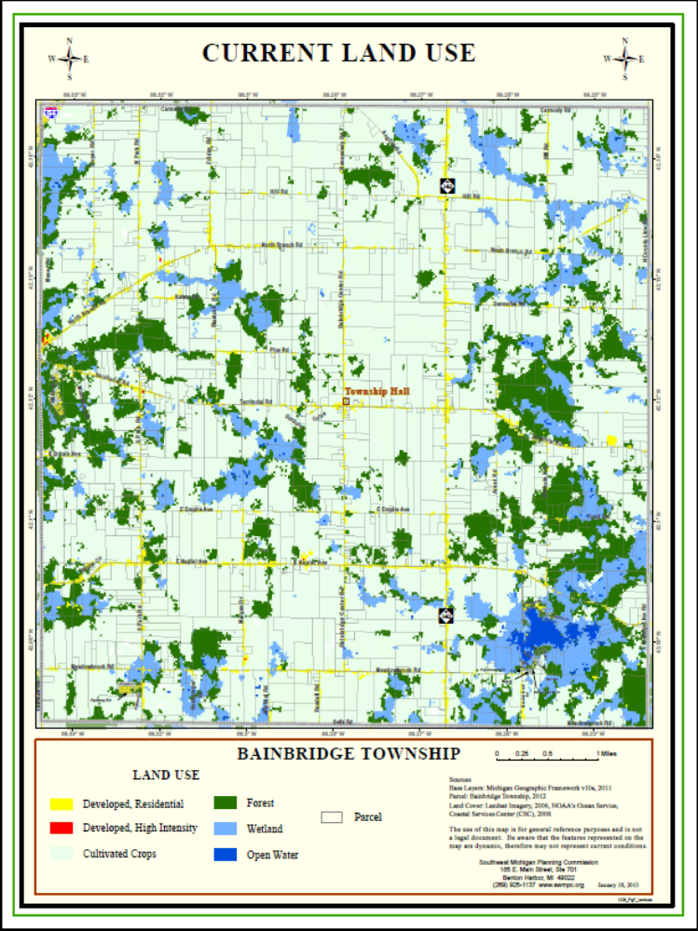

FIGURE 2 – 2020 FUTURE LAND USE MAP

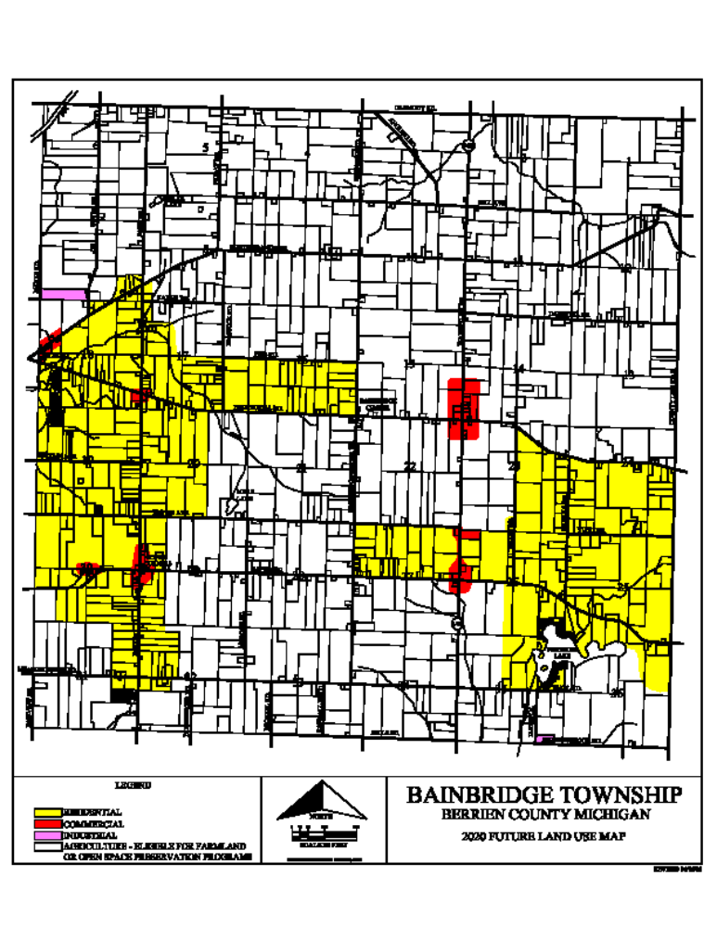

FIGURE 3 – 2002 AGRICULTURAL USE MAP

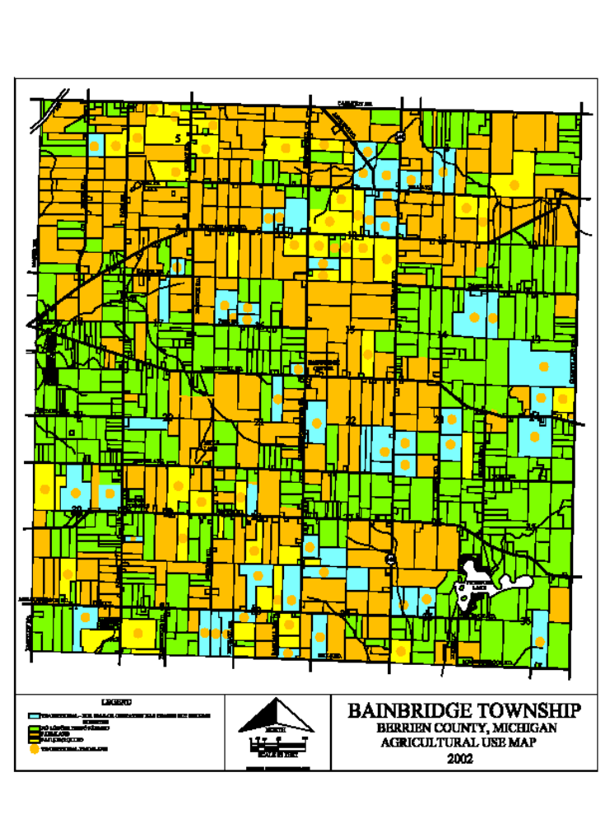

FIGURE 4 – CURRENT AGRICULTURAL
LAND USE

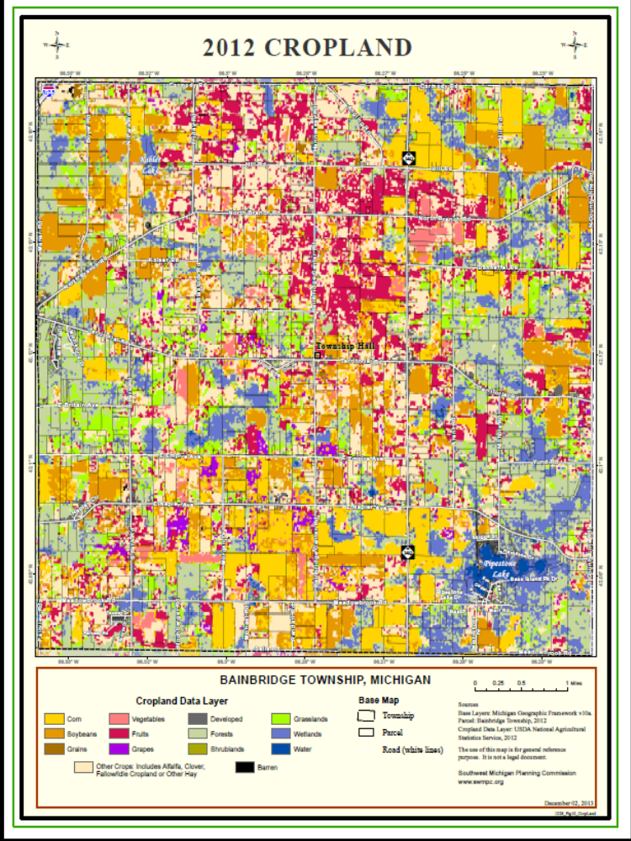

VALUE | CLASS_NAME | ACRES | PERCENT
1 | Corn | 2722.10 | 12.047%
5 | Soybeans | 2554.86 | 11.307%
21 | Barley | 2.67 | 0.012%
24 | Winter Wheat | 36.92 | 0.163%
27 | Rye | 4.00 | 0.018%
28 | Oats | 16.23 | 0.072%
36 | Alfalfa | 572.89 | 2.535%
37 | Other Hay/Non Alfalfa | 437.23 | 1.935%
42 | Dry Beans | 5.78 | 0.026%
43 | Potatoes | 3.56 | 0.016%
48 | Watermelons | 20.91 | 0.093%
49 | Onions | 0.67 | 0.003%
50 | Cucumbers | 90.29 | 0.400%
58 | Clover/Wildflowers | 3.34 | 0.015%
59 | Sod/Grass Seed | 37.81 | 0.167%
61 | Fallow/Idle Cropland | 36.25 | 0.160%
66 | Cherries | 649.17 | 2.873%
67 | Peaches | 119.20 | 0.528%
68 | Apples | 1659.95 | 7.346%
69 | Grapes | 247.30 | 1.094%
70 | Christmas Trees | 3.78 | 0.017%
111 | Open Water | 122.76 | 0.543%
121 | Developed/Open Space | 731.68 | 3.238%
122 | Developed/Low Intensity | 568.44 | 2.516%
123 | Developed/Med Intensity | 28.02 | 0.124%
124 | Developed/High Intensity | 3.11 | 0.014%
131 | Barren | 16.01 | 0.071%
141 | Deciduous Forest | 3855.87 | 17.065%
142 | Evergreen Forest | 15.57 | 0.069%
143 | Mixed Forest | 14.90 | 0.066%
152 | Shrubland | 74.06 | 0.328%
171 | Grassland Herbaceous | 1554.76 | 6.881%
181 | Pasture/Hay | 4052.69 | 17.936%
190 | Woody Wetlands | 1954.40 | 8.650%
195 | Herbaceous Wetlands | 11.12 | 0.049%
206 | Carrots | 1.78 | 0.008%
207 | Asparagus | 207.27 | 0.917%
216 | Peppers | 20.24 | 0.090%
220 | Plums | 0.44 | 0.002%
222 | Squash | 31.58 | 0.140%
229 | Pumpkins | 19.35 | 0.086%
242 | Blueberries | 72.72 | 0.322%
244 | Cauliflower | 9.12 | 0.040%
246 | Radishes | 4.67 | 0.021%
 |  | 22595.45

FIGURE 5 – USGS DESIGNATED FLOODPLAINS AND WETLANDS

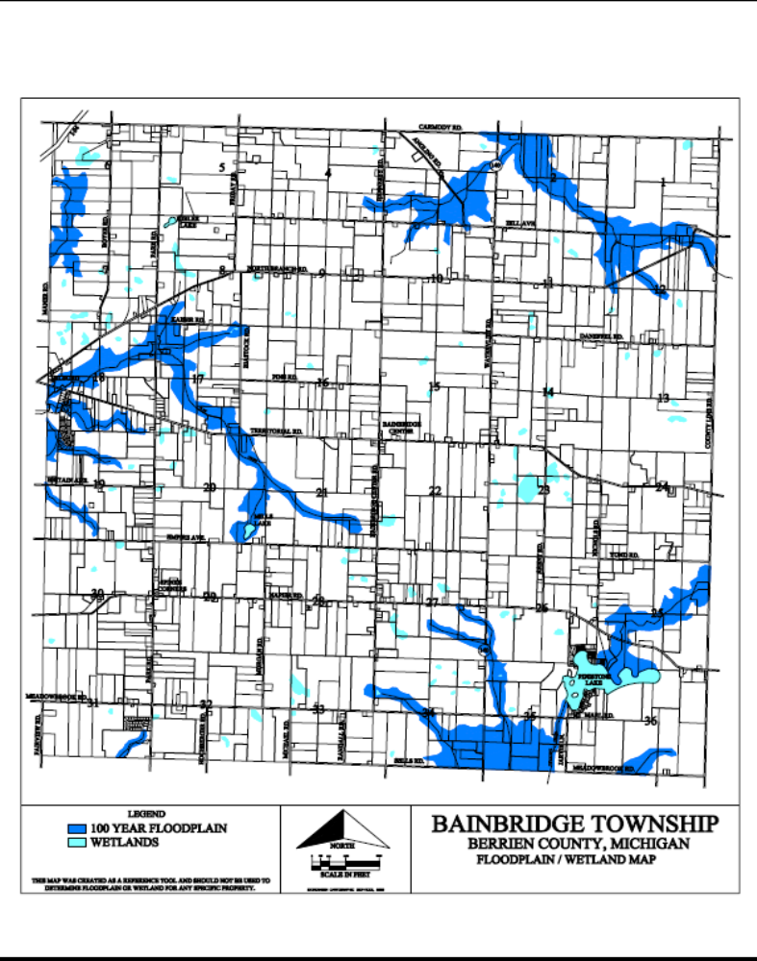

FIGURE 6 – 2025 PROJECTED FUTURE LAND
USE PLAN MAP

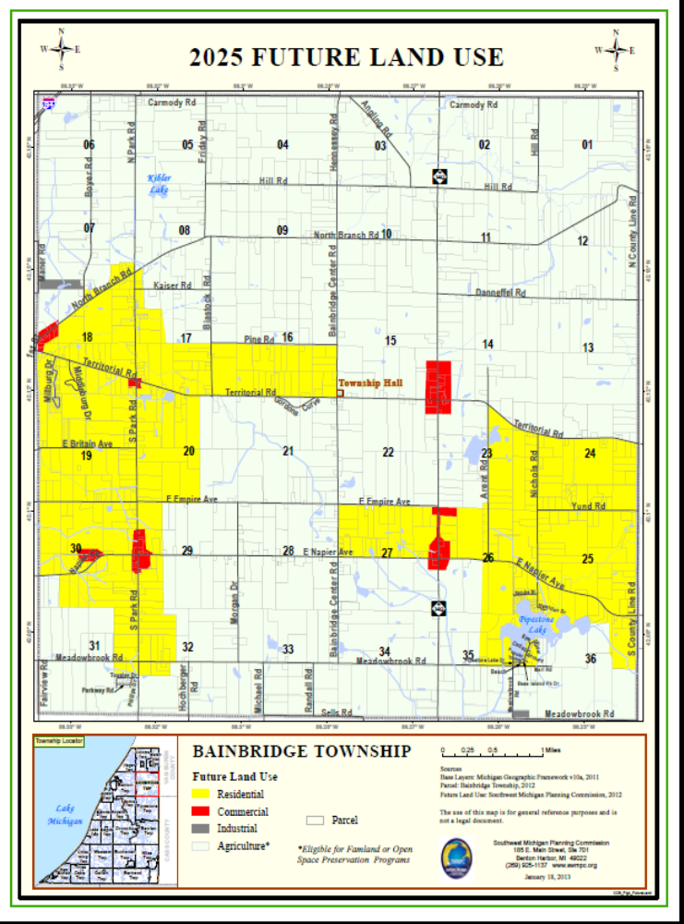

FIGURE 7 – LAND DIVISIONS FOR
PREVIOUS FIVE YEARS

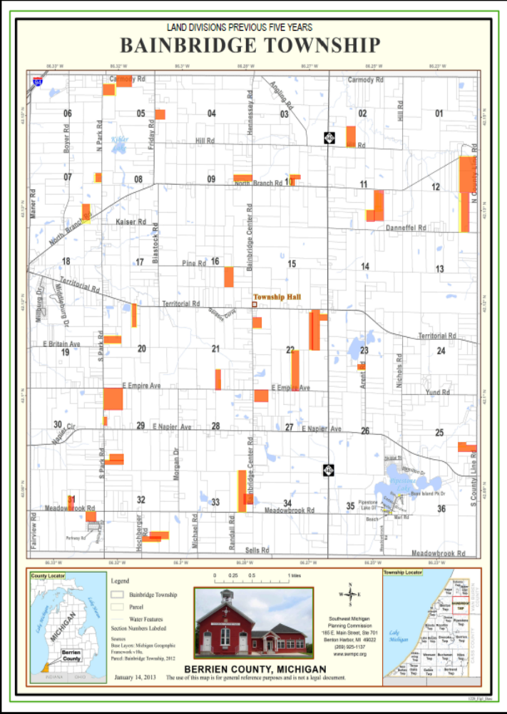

FIGURE 8 – NEW HOME CONSTRUCTION FOR PREVIOUS FIVE YEAR PERIOD

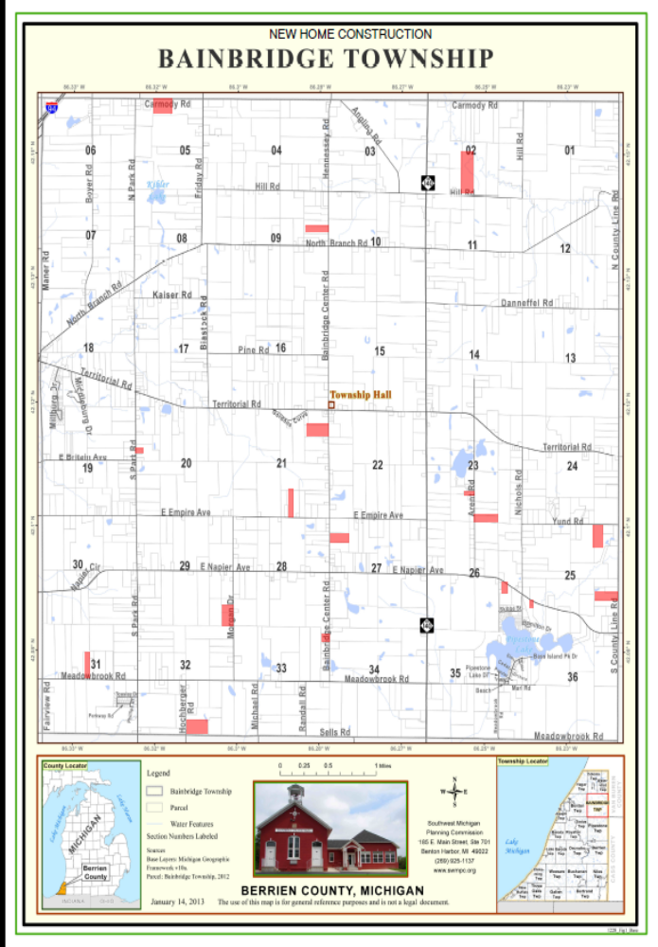

APPENDIX

- NOTIFICATION OF COMMENCEMENT
- BOARD OF TRUSTEES RIGHT OF APPROVAL
- BOARD OF TRUSTEES REVIEW AND RELEASE
- NOTIFICATION AND TRANSMITTAL TO COUNTY PLANNING COMMISSION AND ABUTTING LOCAL UNITS OF GOVERNMENT
- PROOF OF PUBLICATION FOR PUBLIC HEARING
- PLANNING COMMISSION ADOPTION
- BOARD OF TRUSTEES ENDORSEMENT

NOTIFICATION OF COMMENCEMENT
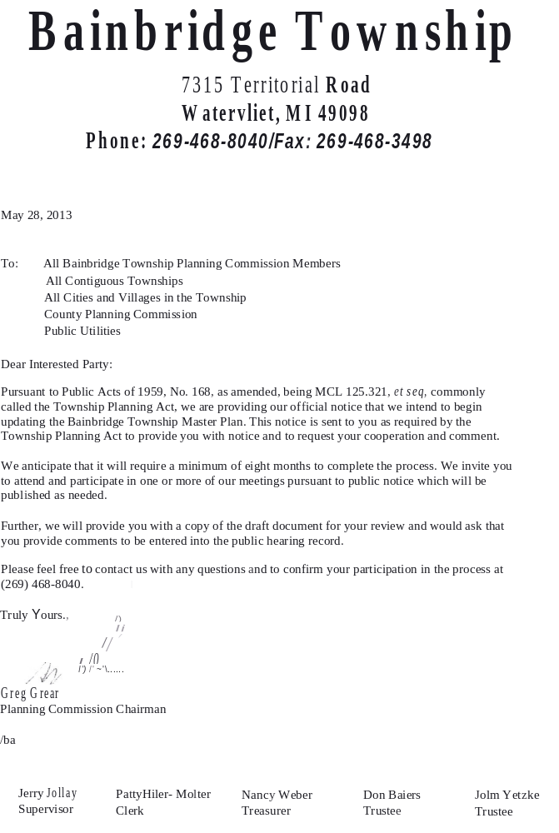

BOARD OF TRUSTEES RIGHT OF APPROVAL

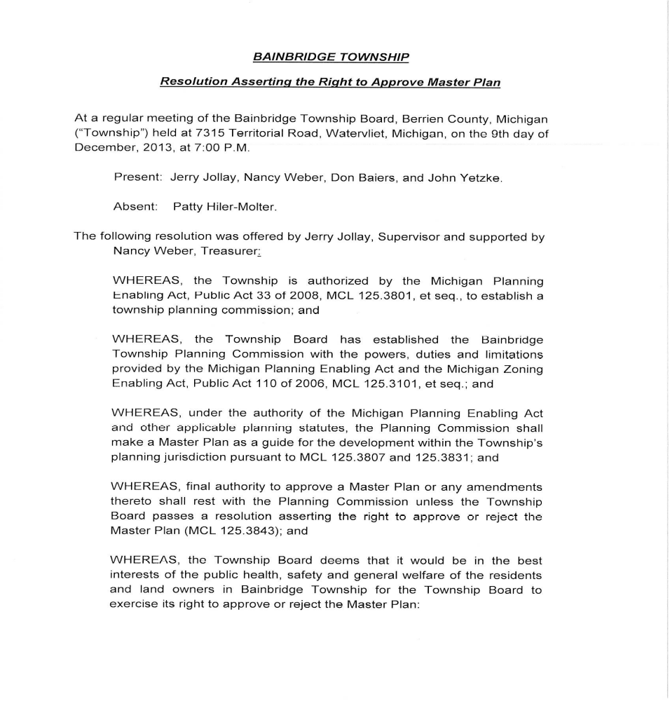

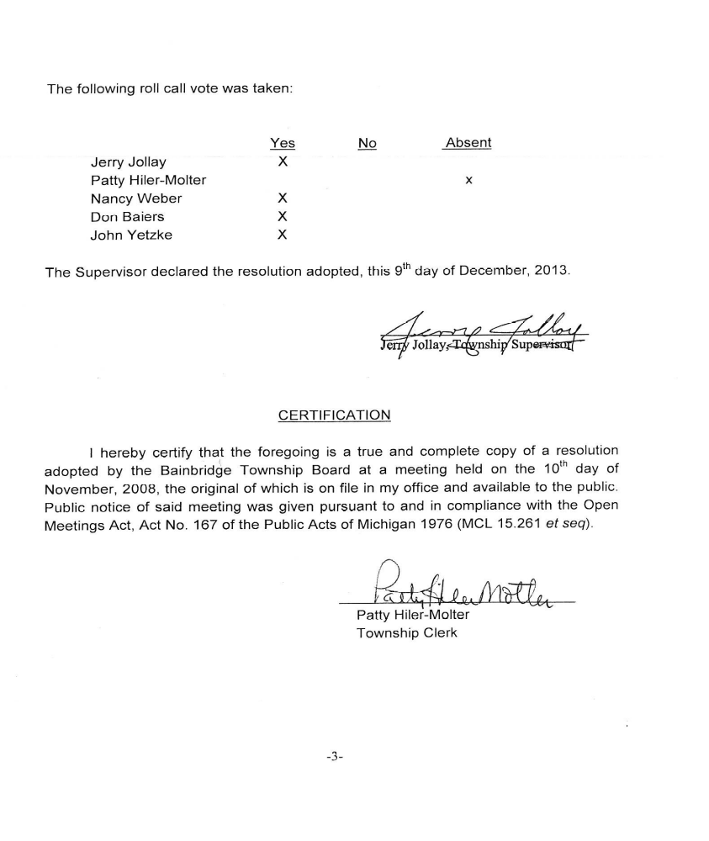

BOARD OF TRUSTEES REVIEW AND RELEASE

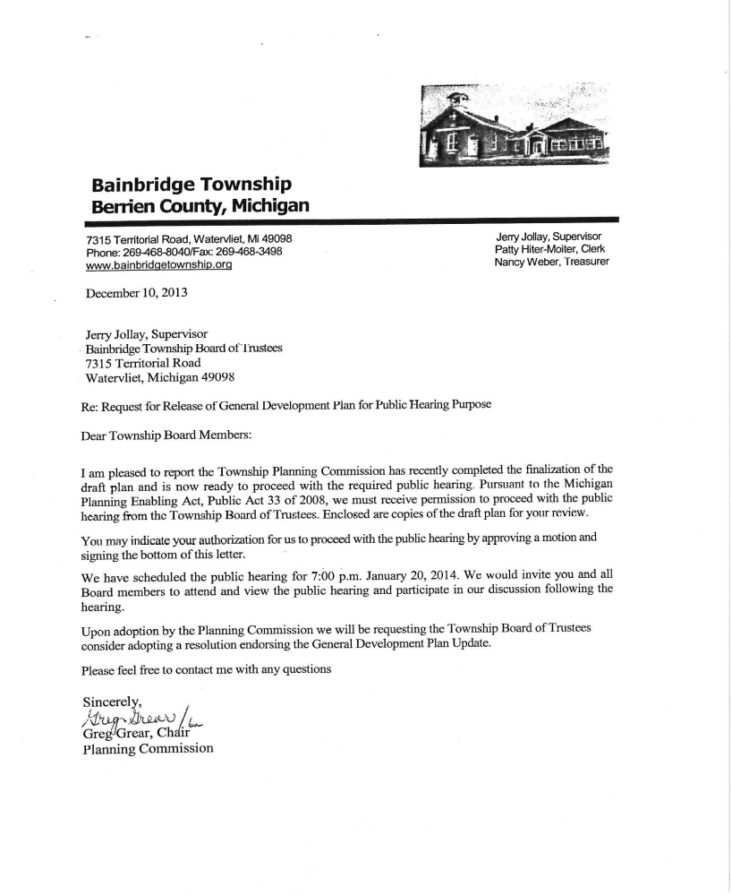

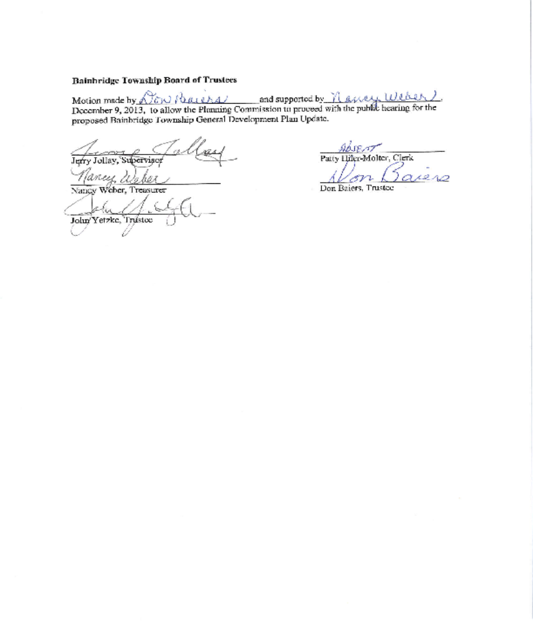

NOTIFICATION AND TRANSMITTAL TO
COUNTY PLANNING COMMISSION
AND ABUTTING LOCAL UNITS OF
GOVERNMENT
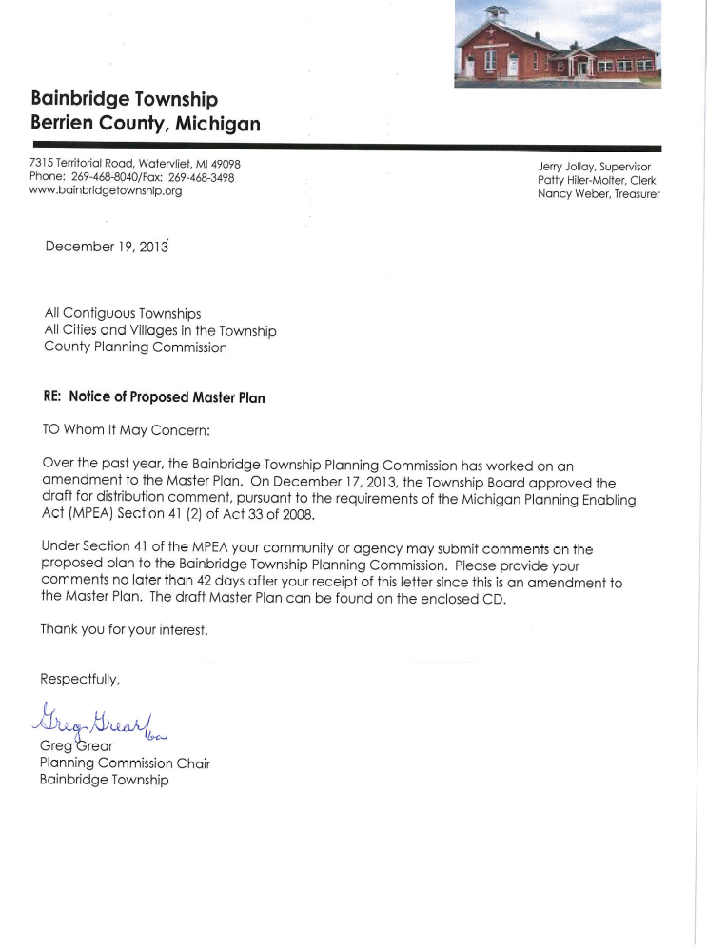

PROOF OF PUBLICATION FOR PUBLIC HEARING

PUBLIC NOTICE
BAINBRIDGE TOWNSHIP
GENERAL DEVELOPMENT PLAN UPDATE

The Bainbridge Township Planning Commission will hold a public hearing on the 20th day of January, 2014 at 7:00 p.m. at the Bainbridge Township Hall located at 7315 Territorial Road, Watervliet, Michigan, 49098. The purpose of the public hearing is to hear public comments regarding the adoption of the General Development Plan Update 2014 for Bainbridge Township. The Update will revise the Future Land Use Map and update text of the current General Development Plan Update 2009.

Please take further notice that the tentative text of the above request may be examined prior to the date of the hearing by calling the Bainbridge Township Hall (269 468-8040) where written comments will be received concerning the request until the hearing.
The Township will provide necessary reasonable auxiliary aids and services to those with disabilities planning to attend upon three (3) days notice to the Township Clerk. If you require such aids or services and plan to attend this meeting please call the Township.

BY ORDER OF THE BAINBRIDGE
TOWNSHIP PLANNING COMMISSION

Greg Grear, Chairman
Planning Commission

PLANNING COMMISSION ADOPTION

BAINBRIDGE TOWNSHIP PLANNING COMMISSION

ADOPTION RESOLUTION

BAINBRIDGE TOWNSHIP
GENERAL DEVELOPMENT PLAN UPDATE

WHEREAS, the Township Rural Zoning Act, Act 184, P.A. 1943, as amended through 1978, stipulates the provisions of a Township Zoning Ordinance should be based upon a plan designed to promote the public health, safety, morals, and general welfare, to encourage the use of lands in accordance with their character and adaptability and to limit the improper use of land, among other things; and

WHEREAS, the Michigan Planning Enabling Act, Public Act 33 of 2008, MCL 125.3801, et seq., effective September 1, 2008, requires that the Planning Commission shall make and adopt a basic plan as a guide for the development of unincorporated portions of the Township, and such plan shall include the Planning Commission's recommendations for the physical development of the unincorporated area of the Township; and

WHEREAS, the Bainbridge Township Planning Commission during the calendar years of 2013/14 has reviewed the current General Development Plan and Future Land Use Map and prepared an updated text and revised Future Land Use Plan Map, for the purpose of encouraging and guiding orderly and efficient future growth and development of the Township; and

WHEREAS, in accordance with Public Act 33 of 2008 with notice of public hearing duly published and invitations to attend and provide comment sent to all abutting municipalities, a public hearing was held on January 20, 2014 at the Bainbridge Township Hall for the purpose of making public explanation of the proposed General Development Plan Update and to receive public comment and recommendations regarding the plan; and

WHEREAS, the Bainbridge Township Planning Commission has given due consideration to public comments presented at the hearing, a public record of which is on file with the Township Clerk.

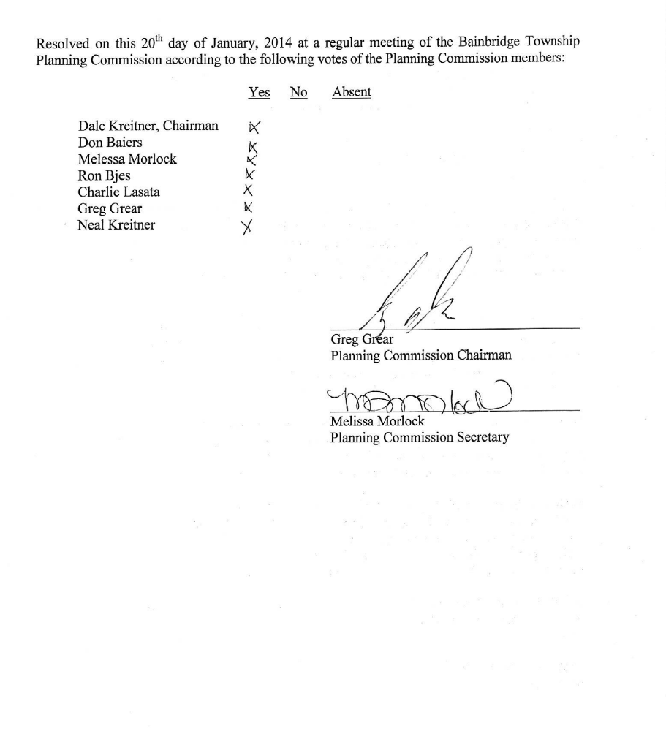

BOARD OF TRUSTEES ENDORSEMENT



